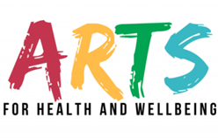
Project Proposal Form
If you would like to propose a project to the Arts for Health and Wellbeing Programme which does not coincide with our current Arts Call Outs, please complete the Project Proposal Form below.

Artist Contact Details

Name:

Email Address:

Phone Number:

Provide a short Artist’s statement/biography.
Write a short summary of project you wish to create.
Why would you like to make this piece for the Arts for Health and Wellbeing Programme?

What will be the final cost of your submission?
How long is the project expected to take from start to completion?

Please email the completed form with any examples of your work to simone.joslyn@wales.nhs.uk

